EJS [EMBEDDED JAVA SCRIPT TEMPLATES]

Link: ejs.co
Documentation: https://github.com/mde/ejs/wiki/Using-EJS-with-Express

REFRESHER
Framework | A framework is usually a library or some other piece of software that provides a skeleton for your application. It provides generic things that almost all applications need.  A programming language tells the computer what it should do. Every programming language features a syntax and a particular set of rules, which need to be followed every time the code is written.  A software framework is built on top of a programming language.  https://hackr.io/blog/what-is-frameworks
JavaScript | - Programming language  - Allows you to make Websites interactive and engages with the user
NodeJS | - Back-end JavaScript platform and environment (and not a framework)  - A platform that allows JavaScript to be executed outside of the web browser  - It is not a framework but only a runtime environment to run JavaScript on server-side.  - NodeJS, as a package, contains an interpreter and a compiler.
Express | - Web framework written in JavaScript and hosted by NodeJS.
EJS | - Is a templating engine used by NodeJS  You define HTML pages in the EJS syntax and you specify where various data will go in the page. Then, your app combines data with the template and "renders" a complete HTML page where EJS takes your data and inserts it into the web page according to how you've defined the template.  https://stackoverflow.com/questions/64144316/what-is-ejs-what-is-the-use-of-ejs  A template engine enables you to use static template files in your application. At runtime, the template engine replaces variables in a template file with actual values, and transforms the template into an HTML file sent to the client. This approach makes it easier to design an HTML page.  Some popular template engines that work with Express are Pug, Mustache, and EJS.  https://expressjs.com/en/guide/using-template-engines.html

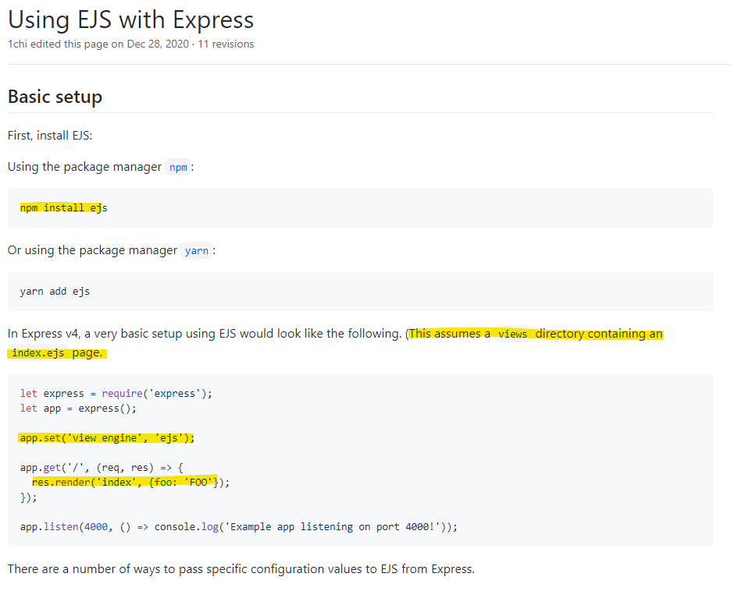

USING EJS
- Install ejs package manager:
$ npm install ejs
- Create a folder named “views”. This folder will contain your .ejs pages.
- Create your .ejs file inside the “views” folder.
- In your .js file, add the following lines:
app.set(“view engine”, “ejs”); // setting the view engine to EJS.

app.get(“/”, (req, res)=>{
res.render(“<ejs file>”, {<variable name in ejs>, <value to be passed>
});
- Go to your .ejs file, it contains basically your HTML codes but with javascript data inserted in it using its tags.
<%= ejs_variable_name %>
<% js control code %>

<% 'Scriptlet' tag, for control-flow, no output
<%_ ‘Whitespace Slurping’ Scriptlet tag, strips all whitespace before it
<%= Outputs the value into the template (HTML escaped)
<%- Outputs the unescaped value into the template
<%# Comment tag, no execution, no output
<%% Outputs a literal '<%'
%> Plain ending tag
-%> Trim-mode ('newline slurp') tag, trims following newline
_%> ‘Whitespace Slurping’ ending tag, removes all whitespace after it

Source: https://stackoverflow.com/questions/3552461/how-to-format-a-javascript-date

If you need slightly less control over formatting than the currently accepted answer, Date#toLocaleDateString can be used to create standard locale-specific renderings. The locale and options arguments let applications specify the language whose formatting conventions should be used, and allow some customization of the rendering.

Options key examples:
day:
The representation of the day.
Possible values are "numeric", "2-digit".
weekday:
The representation of the weekday.
Possible values are "narrow", "short", "long".
year:
The representation of the year.
Possible values are "numeric", "2-digit".
month:
The representation of the month.
Possible values are "numeric", "2-digit", "narrow", "short", "long".
hour:
The representation of the hour.
Possible values are "numeric", "2-digit".
minute: The representation of the minute.
Possible values are "numeric", "2-digit".
second:
The representation of the second.
Possible values are "numeric", 2-digit".

All these keys are optional. You can change the number of options values based on your requirements, and this will also reflect the presence of each date time term.

Note: If you would only like to configure the content options, but still use the current locale, passing null for the first parameter will cause an error. Use undefined instead.

For different languages:
"en-US": For English
"hi-IN": For Hindi
"ja-JP": For Japanese

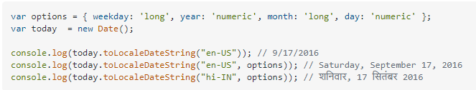

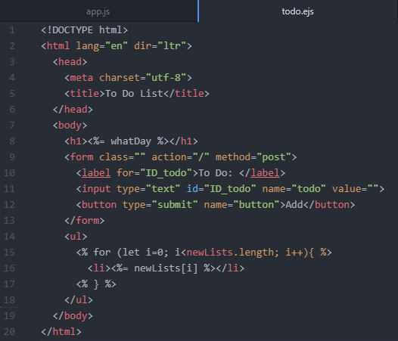

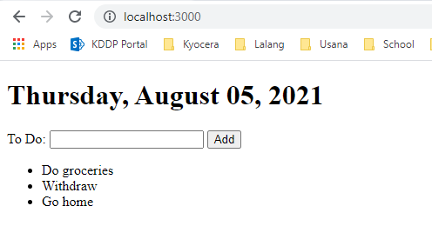

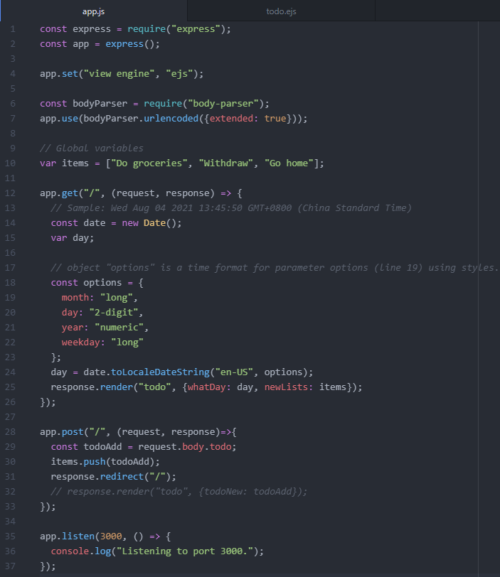
The Module Object:
Documentation: https://nodejs.org/dist/latest-v16.x/docs/api/modules.html#modules_the_module_object

date.js
(this is an incomplete module with nothing exported)
- console.log(module);

- function getDate() {
- // Sample: Wed Aug 04 2021 13:45:50 GMT+0800 (China Standard Time)
- const date = new Date();

- // object "options" is a time format for parameter options (line 19) using styles.
- const options = {
- month: "long",
- day: "2-digit",
- year: "numeric",
- weekday: "long",
- };
- return date.toLocaleDateString("en-US", options);
- }
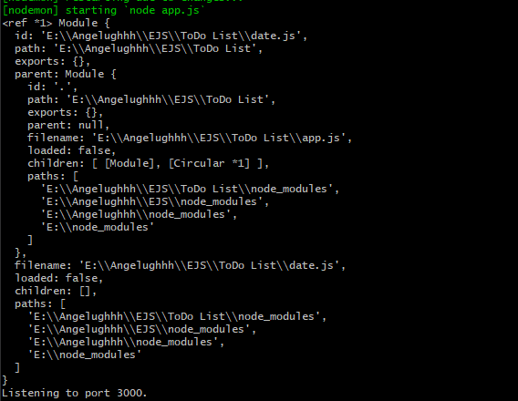

NOTE:
I don’t understand why there are double backslashes displayed on the path strings.

day.js Module
Module {
this is where your module is located and is currently in a local directory
id: 'E:\\Angelughhh\\EJS\\ToDo List\\date.js',
path: 'E:\\Angelughhh\\EJS\\ToDo List',

this property exports is a js object (as denoted by the curly braces)
at the moment, this indicates that your day.js module is not exporting anything
exports: {},

the actual parent module’s details that launched/required this day.js module
parent:
Module {
id: '.',
path: 'E:\\Angelughhh\\EJS\\ToDo List',
exports: {},
parent: null,
parent module (of day.js) is app.js
filename: 'E:\\Angelughhh\\EJS\\ToDo List\\app.js',
loaded: false,
example of the children property are the required express and body-parser
children: [ [Module], [Circular *1] ],
paths: [
'E:\\Angelughhh\\EJS\\ToDo List\\node_modules',
'E:\\Angelughhh\\EJS\\node_modules',
'E:\\Angelughhh\\node_modules',
'E:\\node_modules'
]
},
filename: 'E:\\Angelughhh\\EJS\\ToDo List\\date.js',
loaded: false,
children: [],
paths: [
'E:\\Angelughhh\\EJS\\ToDo List\\node_modules',
'E:\\Angelughhh\\EJS\\node_modules',
'E:\\Angelughhh\\node_modules',
'E:\\node_modules'
]
}
Listening to port 3000.

Module.Exports
File: app.js
- const date = require(__dirname + "/date.js");
- console.log("Module 'date.js': ", date);
Line 01:
date.js is a local node module (and not yet located in the server) so it needs an additional __dirname to locate it.

Once the code runs, it will try to execute all the code inside date.js first and bind it to const "date" before proceeding to run the next line of code (in this case, Line 02) in app.js.

File: day.js
- module.exports = getDate;
- console.log(module);

- function getDate() {
- // Sample: Wed Aug 04 2021 13:45:50 GMT+0800 (China Standard Time)
- const date = new Date();

- // object "options" is a time format for parameter options (line 19) using styles.
- const options = {
- month: "long",
- day: "2-digit",
- year: "numeric",
- weekday: "long",
- };
- return date.toLocaleDateString("en-US", options);
- }
Line 01:
With .exports this current date.js module will export its equivalent value or function.

In JavaScript Objects, when adding parenthesis after a function name, you are executing/invoking the function.
getDate function has no parenthesis so we can allow app.js (parent module) to determine when to invoke the function.

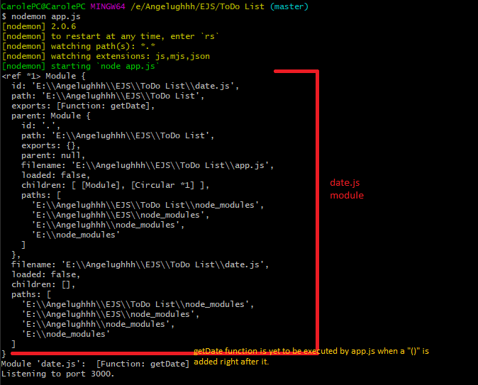

module.exports is a JavaScript object and objects have properties and methods associated with it.

Note: If you would only like to configure the content options, but still use the current locale, passing null for the first parameter will cause an error. Use undefined instead.

Pushing to Git returning Error Code 403 fatal: HTTP request failed
https://stackoverflow.com/questions/7438313/pushing-to-git-returning-error-code-403-fatal-http-request-failed
https://docs.github.com/en/github/authenticating-to-github/connecting-to-github-with-ssh/about-ssh
